Overview
The following instructions step through the process of manually configuring your Office 365 Exchange Online account with Outlook 2010 and 2013 for Windows. This may be needed when configuring secondary account or if you run into issues with the automatic configuration process.
Note: Outlook 2016 only supports the Auto-discover process for adding Exchange Online accounts. The following instructions do not apply.

This tutorial applies to the following operating system(s):
- WINDOWS

Step 1
Open the Control Panel.

Step 2
Click Mail.
*Note: If you do not see the Mail option, change your View by setting to Large Icons or Small Icons.
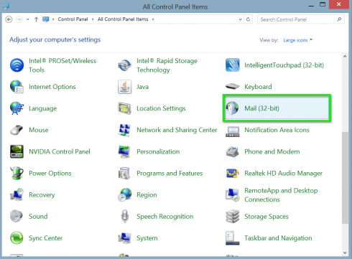

Step 3
Click E-mail Accounts...
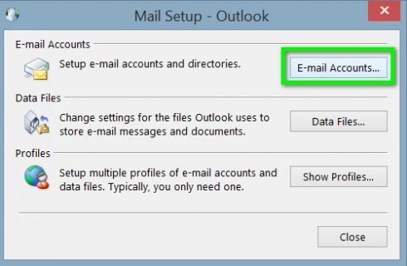

Step 4
Click New...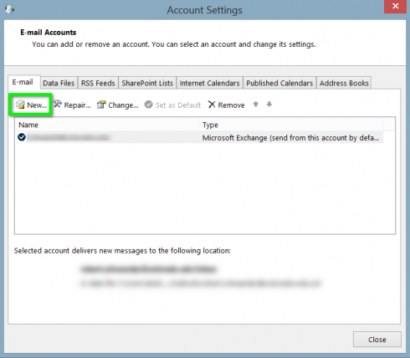

Step 5
Select Manual setup or additional server types, then click Next.
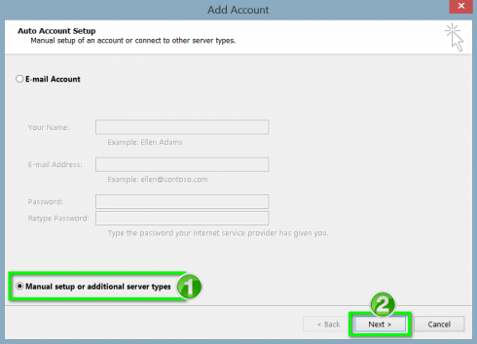

Step 6
Select Microsoft Exchange Server or compatible service, then click Next.
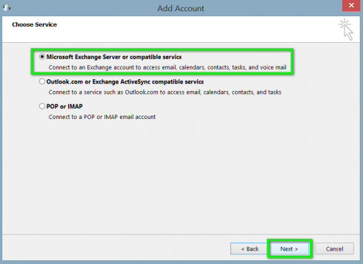

Step 7

Enter the following in the corresponding fields:

Server: outlook.office365.com

User Name: Login name
When finished, click More Settings *Note: Do not click the Check Name button at this step, or the configuration process will fail.
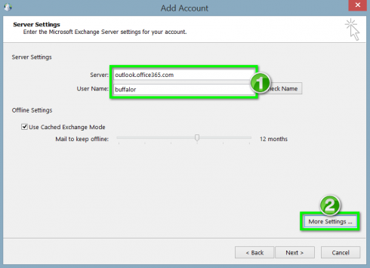

Step 8
Click the Security tab.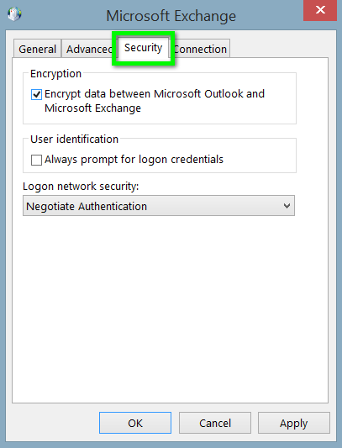

Step 9
Adjust the following settings:
- Uncheck Encrypt data between Microsoft Outlook and Microsoft Exchange.
- Choose Anonymous Authentication from the Logon network security drop-down menu.
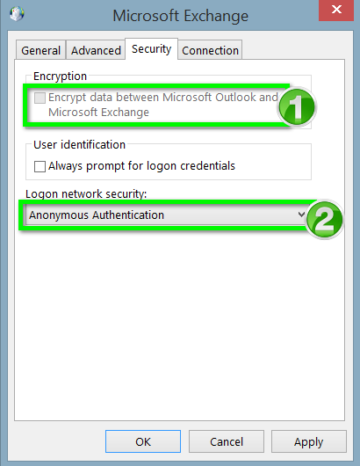

Step 10
In the Connection tab, check Connect to Microsoft Exchange using HTTP, then click Exchange Proxy Settings...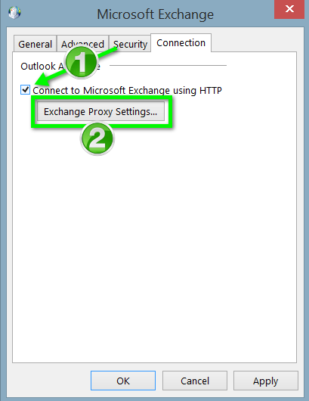

Step 11
In the Use this URL to connect to my proxy server for Exchange field, enter outlook.office365.com.
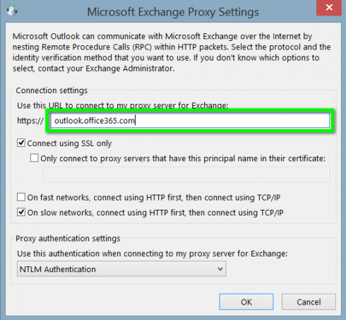

Step 12
Check the Only connect to proxy servers that have this principal name on their certificate, then enter msstd:outlook.com in the associated text field.
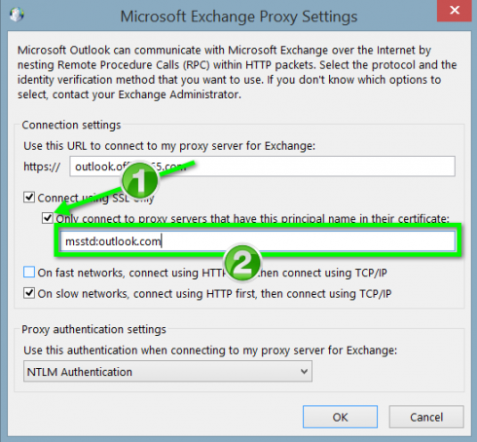

Step 13
Adjust the following settings:
- Check the On fast networks, connect using HTTP first then connect using TCP/IP box.
- Select Basic Authentication from the Use this authentication when connecting to my proxy server for Exchange drop-down menu.
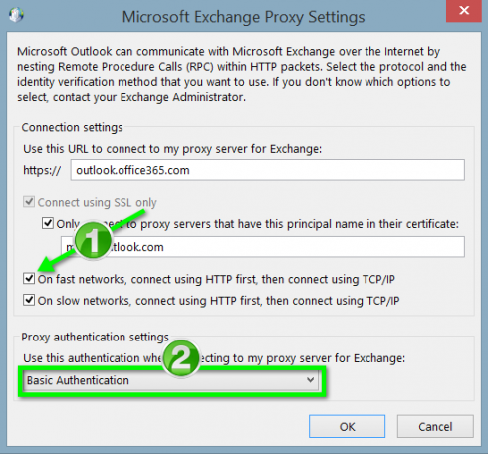

Step 14
Click OK.
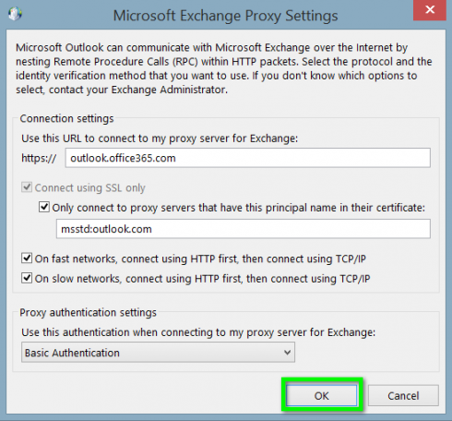

Step 15
Click OK.
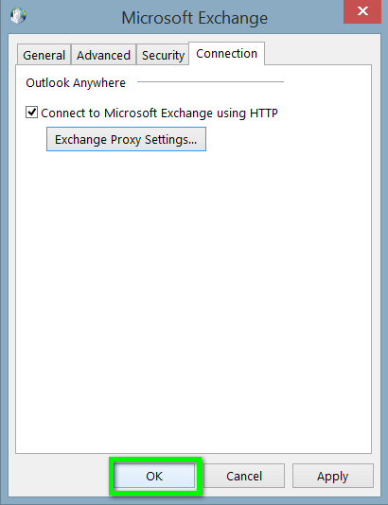

Step 16
Click Check Name.
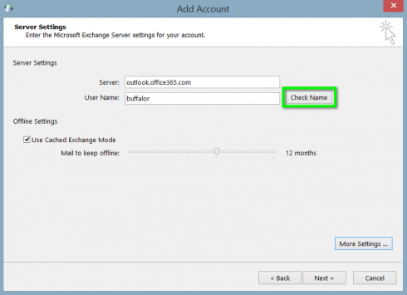

Step 17
An authentication prompt will appear. Enter your LoginName@domainname.com.au and password in the corresponding fields, then click OK.
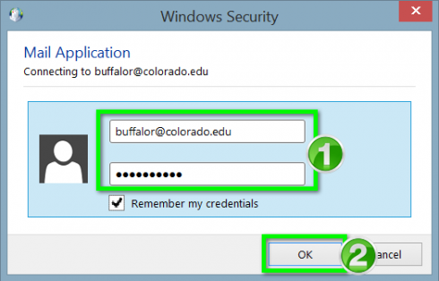

Step 18
Click Next >.
.
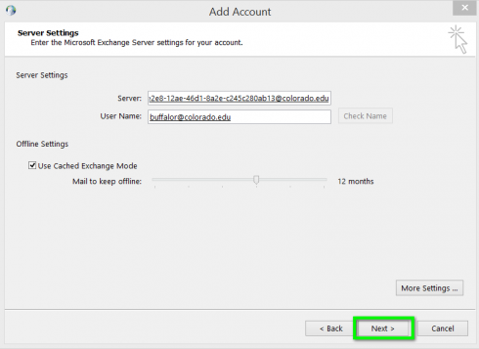

Step 19
Click Finish. Your account will be setup and you can open Outlook to begin using your Exchange account.
